The activity diagram shows the how those activities depend on one another.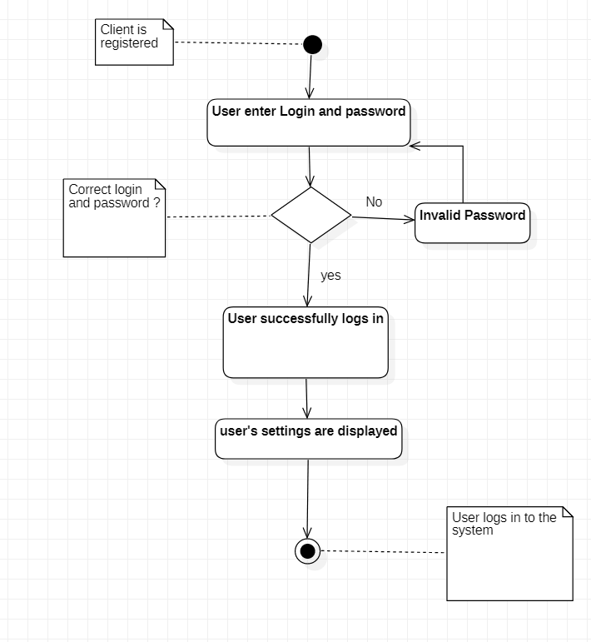 Here the main activity it the login of user. The diagram will start when user enter login and password. After there is decision choice. The question is: Correct login and password?

False:

* Try again and enter again your ID| Password

True:

* User successfully logs in
* User’s settings are displayed

End (User logs in to the system

This diagram is basic but important to understand how work login process.